MEMS 1043
Senior Design
Spring 2025

Milestone II

Adopted Design

Sponsor

Dr. Ian Sigal
(Ian.sigal@gmail.com)

Team Members and Roles

Coordinator Karan Choudhari kac518@pitt.edu
Planner James Puzon tjp79@pitt.edu
Resource Manager Lowell Shaw lhs26@pitt.edu
Resource Manager Logan Radomicki clr107@pitt.edu
Presenter Max Mongiello mjm459@pitt.edu

1. Swanson Center for Product Innovation

Our team does not anticipate the use of any SCPI resources.

2. Preliminary Design Concepts

Candidate Design Concepts

Concept 1: Compliant Mechanism
To develop a stop method for the yarn surrogate, a clip was designed mechanically with the intent to trap yarn after the structure is completed. The clip will work without external electronics and will be modular and placeable on any nail. When the robot is finished building the yarn structure, it will travel to the nail holding the clip, bringing the yarn within its middle area. After, it will directly apply force to the top of the clip, resulting in a clamp holding the yarn in place by friction. The clip will also contain rubber or rubber-adjacent materials, to increase the friction holding the yarn. Prototyping will be required to increase the opening of the clip, to allow for a higher degree of freedom for the end effector to bring the yarn into the clip.
The primary design elements of the clip will be the attaching mechanism to the nail, as well as how to trap the yarn in the first place. Initial design elements were limited to a specific entry direction for the yarn and was slotted onto the nail. Newer designs increase the opening for the end effector resulting in more freedom for end effector movement and also has more surface area for the end effector to apply pressure to close the clip. Further designing will be useful in creating a tighter fit capable of holding the yarn more securely.

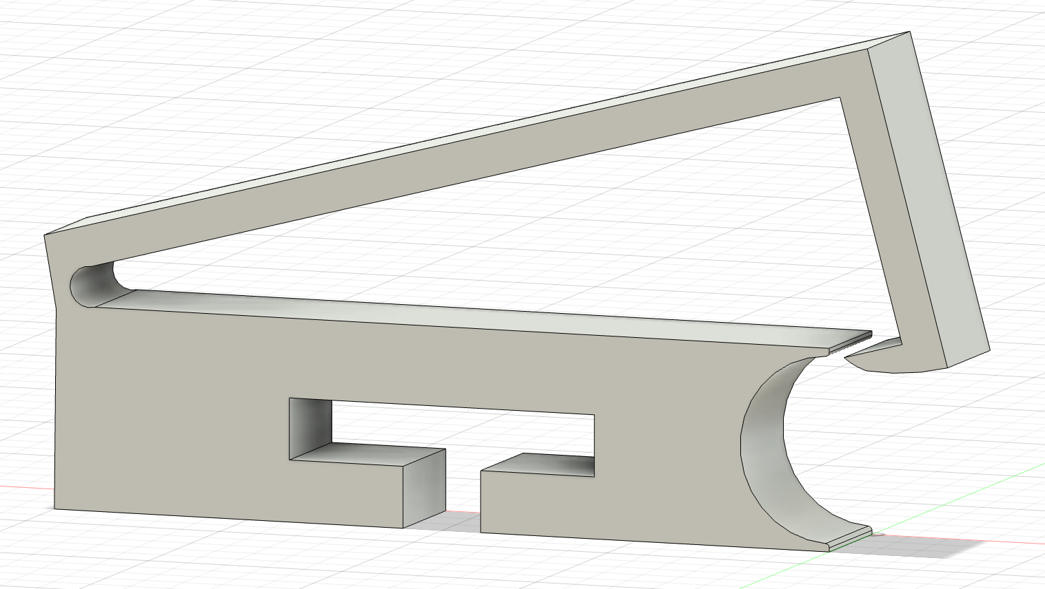
Figure 1. First design of the clip, with limitations on yarn entrance.
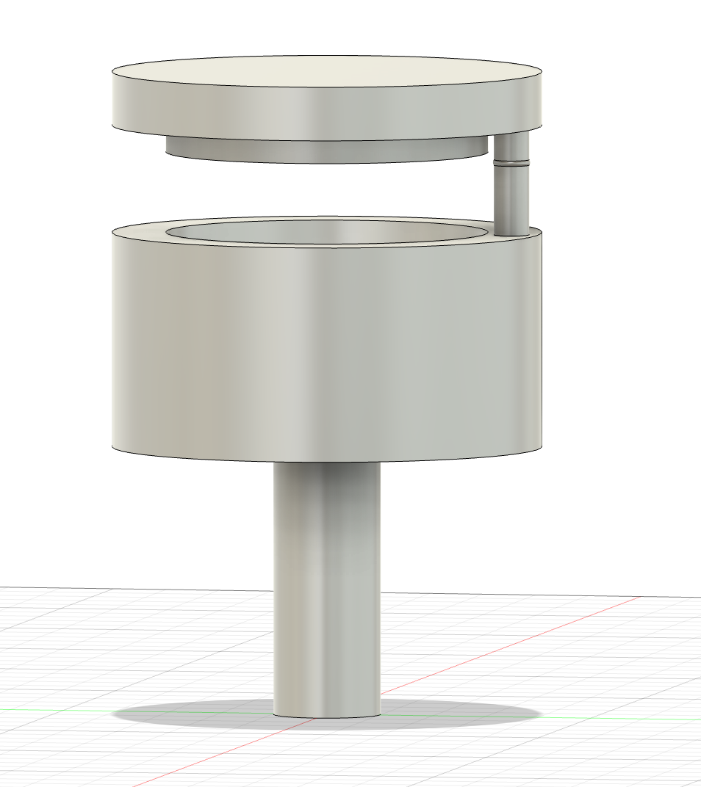

Figure 2. Second design of the clip, improving yarn entrance.

Concept 2: Weaving End Effector
Previously, the Laboratory of Ocular Biomechanics had designed an end effector for a 2-axis robot that allowed “weaving” of a fiber around another pre-existing fiber. This mechanism, shown in Figure , had two major issues preventing it from being applied.
First, it was extremely mechanically complex. Second, it could not dispense fiber in the manner required for creating 3D fiber structures.

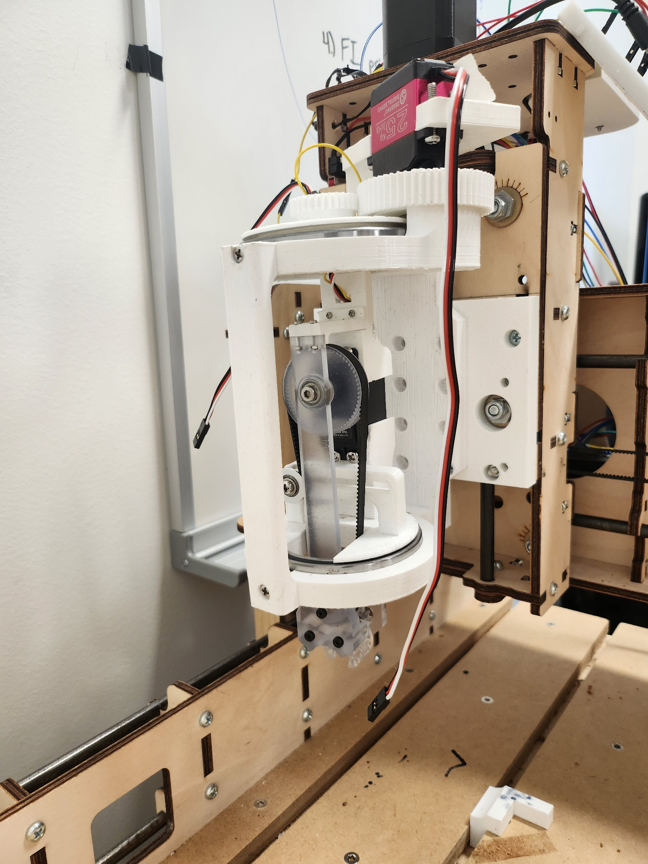
Our second design concept is a redesign of this mechanism, with the main objectives being to allow fiber dispensing and adapt it to the robot. One advantage of using a robot arm (as opposed to a 2-axis robot) is that the arm is capable of rotating the end effector; this will eliminate much of the complexity of the previous design.

Figure 3. Image of previous weaving mechanism. Most of the mechanical complexity came from the requirement for the end effector to rotate to any preexisting fiber orientation, necessitating slip rings and an elaborate powertrain.
We have already developed three iterative prototypes of this design and believe both objectives are possible. A photo of the first design and a SOLIDWORKS model of the latest prototype are shown in Figure .

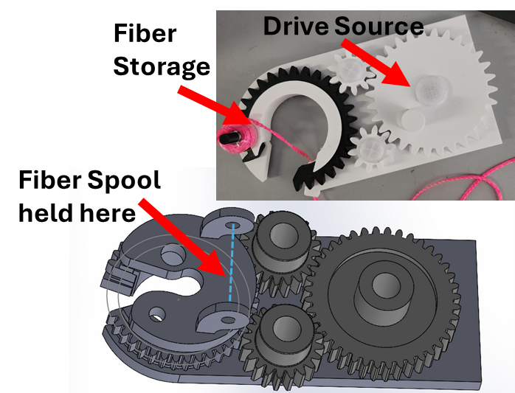
Figure 4. First prototype (photo) and CAD model of 3rd Prototype

All three mechanisms function by bringing the preexisting fiber into the ‘jaw’ of the mechanism (the c-shaped spur gear). Once the fiber is in place, rotating the mechanism 360˚ wraps the dispensing fiber around the preexisting one, creating a woven joint. To allow for thread to be dispensed independently of weaving, the fiber supply must be located on the rotating jaw. If this is not done, the fiber will become tangled. Similarly, the tube through which fiber is dispensed must rotate with the jaw to avoid tangling.

A final version of this design would include motorized jaw motion and keep the size of the jaw as small as possible, to maximize resolution of the fiber structures (if the jaw is wider, the spacing between fibers must be larger to accommodate this).

Concept 3: Magnetic Carriage

In order to achieve a woven fibrous structure, this design employs a combination of magnets and compliant mechanism design to produce a magnetically suspended surrogate guide and spool capable of passing thread between it and the robot. The system unspools thread from its bottom-most surface and is comprised of two distinct parts. The first is a base plate with permanent magnet sites which attaches to the robot following the standards established in previous prototypes. The second part is comprised of several thin struts extruded from a base structure capable of mounting and dispensing surrogate fiber. At the ends of the thin extrusions are conjugate magnets (electro-magnets or permanent were not determined prior to design direction changes), which attract complimentary magnets on the robot side.

In order to achieve weaving, given an existing fiber to weave around, the robot would need to position the end effector such that the thread holding base plate is at a lower height off the table than the target fiber, and the upper base plate is higher than the target fiber. The robot then need only move horizontally “through” the target fiber until the entire end effector has passed the fiber.

When the target fiber comes into contact with the magnetic strut, given sufficient target fiber tension and robot arm force, the strut will begin to deform in bending, resulting in the separation of the conjugate magnets on the base and strut, and creating a gap through which the thread can pass. The two parts will remain partially in contact due to the remaining magnetic struts. After a critical horizontal distance travelled the thread will have moved beyond reach of the magnetic strut and the elastic deformation of the strut will reverse. This action will realign the conjugate magnets, thus regaining support characteristics. Utilizing the 360 degree rotation in (plane with the table) the robot arm is capable producing natively, a proper angle of attack can be determined to ensure a stable mechanical connection between both parts through the motion. A proper angle of attack passes the end effector through the fiber in such a rotation where the number of deformed struts in any position during the motion does not exceed the critical number of deformed struts to cause irreversible separation of the two parts.

If all necessary conditions for operation are met, the result is a mechanically focused (barring electromagnet use and reliance on the robot arm) end effector capable of weaving a fiber around another fiber via a forward pass above the thread and a reverse pass “through” the thread, with the robot returning to the original position the forward pass was initiated from to complete the weaving.

Requirements & Specifications

Concept 1: Compliant Mechanism
Satisfies Requirements:
4. Start and end fiber without human assistance
- this should allow the robot to secure fibers to a fixture point without human intervention.
8. Needs to be able to fix fiber to a point, and continue the fiber afterwards
- as a nail replacement, this design is capable of everything the previous fixtures were.
10. Adapt to different structures –should be able to make anything programmable
- since these can be placed anywhere on the substrate, this requirement should not be an issue.
Satisfies Specifications:
2. Be able to reliably reproduce structures at a success rate greater than 70%
- this may prove challenging for ‘start’ function, but enough design work should make this achievable. ‘stop’ function is not expected to be any less reliable than nails (that is, very reliable).

Other requirements & specifications are not directly applicable due to this design not being an end effector.

Concept 2: Weaving End Effector
Satisfies Requirements:
- End effector must mount on a standard bots RO1
  - It is simple to adapt the design to the RO1 mounting flange, and we do not expect to exceed the 18kg weight limit outlined in specification 1.
- Must dispense fiber under tension
  - Use of a tension assembly or friction fit on rotating parts will allow for control of fiber tension.
- Not abrade fiber too much
  - This should be achievable with proper materials selection for parts in contact with fiber.
6. Not be a danger to people working in the lab
- This design has no significant changes to robot motion, so it is not expected to create any dangerous situations.
7. Be able to create 3D fiber structures
- This design should have all of the same motion and dispensing capabilities of the previous team’s end effector, allowing it to build 3D structures.
8. Needs to be able to fix fiber to a point, and continue the fiber afterwards
- This can be accomplished through programming as long as the end effector reliably dispenses fiber; it should not be an issue.
10. Adapt to different structures –should be able to make anything programmable
- Again, this can be accomplished through programming.

Can Satisfy (with extensive design work)
5. Hold enough fiber to not require replacement during operation
- Because the fiber supply must rotate with the jaw, this is a design challenge. We believe it should be achievable through iterative design.
9. Minimize the size of the end effector tip, to allow for higher-resolution structures
- Careful design of the powertrain and fiber storage will help minimize size, but this is something we will have to focus on.
4. Start and end fiber without human assistance
- Ending fiber may be possible by tying a knot. This will be difficult to program and implement, so it is not a strength of this design.

Satisfies Specifications:
- End effector must weigh less than 18kg and conform to dimensions of connecting flange
  - We do not expect to exceed this weight limit. See requirement #1.
- Be able to reliably reproduce structures at a success rate greater than 70%
  - While this is hard to predict, careful programming and mechatronics design should allow for a high success rate. This will be measured by repeating structures and recording # of fibers dropped, etc.
Concept 3: Magnetic Carriage
Satisfies Requirements:
1. End effector must mount on a standard bots RO1
  - It is simple to adapt the design to the RO1 mounting flange, and we do not expect to exceed the 18kg weight limit outlined in specification 1.
2. Must dispense fiber under tension
  - Use of a tension assembly or friction fit on rotating parts will allow for control of fiber tension.
6. Not be a danger to people working in the lab
- This design has no significant changes to robot motion, so it is not expected to create any dangerous situations.
7. Be able to create 3D fiber structures
- This design should have all of the same motion and dispensing capabilities of the previous team’s end effector, allowing it to build 3D structures.
8. Needs to be able to fix fiber to a point, and continue the fiber afterwards
- If the end effector can consistently dispense fiber, this should be fine
10. Adapt to different structures –should be able to make anything programmable
- Again, this can be accomplished through programming.

Satisfies Specifications:
- End effector must weigh less than 18kg and conform to dimensions of connecting flange
  - We do not expect to exceed this weight limit. See requirement #1.
- Be able to reliably reproduce structures at a success rate greater than 70%
  - Again, this is difficult to predict but should be achievable, providing the mechanism actually works.

Can Satisfy (with extensive design work)
5. Hold enough fiber to not require replacement during operation

Strengths and Weakness

Concept 1: Compliant Mechanism
Strengths:
- Likely simple to build
- No electronics/mechatronics
- Cheap
- Likely simple to program for
- Commercial replacements may exist
Weaknesses:
- Cannot address weaving
- Requires human assembly
- May be single-use
- Could be direction-specific, complicating programming
- Might be difficult to mass-produce
Concept 2: Weaving End Effector
Strengths:
- Can accomplish weaving
- Minimal motorized components
- Uses well-understood mechanisms (gears)
- Can dispense fiber in a fashion similar to the old end effector
Weaknesses:
- requires mechatronics, which also complicates programming
- most expensive option
- gearing/powertrain may be difficult to figure out
- limits resolution of fiber structures
- may reduce fiber capacity
- fiber tie-off will be very complicated to implement
Concept 3: Magnetic Carriage
Strengths:
- if passive, no motorized components
- cheap
- could be much faster than weaving end effector
- simple to use (no additional programming/mechatronics)
Weaknesses:
- significant limitation on resolution (entire thread carriage must be passed around thread to achieve weaving)
- does not use well-known mechanisms (magnets are weird); extensive trial & error anticipated to balance ideal loading conditions)
- limited space for parts to retain tension
- low confidence this design will be successful

Current or Future Supporting Analysis or Validating Experiments

Concept 1: Compliant Mechanism
- many iterations of trial and error on final mechanism; luckily, these are easy to prototype
- possible adhesion/friction calculations for fiber starting, assuming that we will rely on the fixture ‘catching’ a loose fiber.
- Mechanical design of compliant part

Verified if the compliant part actually is compliant and can be used for start/stop. (can it catch a loose fiber and secure it? Can it retain fiber even after tension is released?)

Concept 2: Weaving End Effector
- Mechanical design, stress calculations, and torque/RPM analysis for gears
- Fiber capacity calculations
- Required dimensions based on desired resolution

Verified if motion is smooth and reliable. Future sponsor communication will be required for defining spool/resolution limits.

Concept 3: Magnetic Carriage
- Magnet force calculations
- Deformation/flexure calculations for magnet holders (or trial + error)

Down Select Approach

We will combine out Pugh chart with careful consideration of peer & sponsor feedback to determine which deliverables are most critical. We will then select the design we believe is the best fit.

3. Preliminary Design Review Comments

Reviewing Peer Team

Senior Design Team 4

Peer Team Preliminary Design Review Comments

The primary concerns outlined by our peers include...

- Resolution concerns (thread dispensing component sizing determines the resolution of fibrous structures capable of being made.)

- Orientation Dependence (adds complications to programming and robot control)

Actions
The main concerns highlighted by the peer review directed us to perform research on the sizing capabilities of the 3d printer used to print parts, to ensure that we can directly print the sizes that we designed. To solve orientation dependence, further designing and testing was completed on the clips to increase the angle and area at which the yarn can enter, to reduce the risk of error.

4. Pugh Chart

Figure 5. Pugh Chart of potential designs. In this chart, a higher number is worse. Totals are calculated as a sum of all (1-5) categories, and then a boon of -5 is applied for each (Y/N) objective met.

5. Adopted Design

Adopted Design

Based upon our Pugh chart and our sponsor’s feedback, we have chosen to pursue the ‘Weaving End Effector’ and ‘Compliant Mechanism’ designs.

Detailed Design Description

See Section 2 for detailed written descriptions. Relevant sketches of concepts 1 & 2 are shown below.

Concept 1: Compliant Mechanism
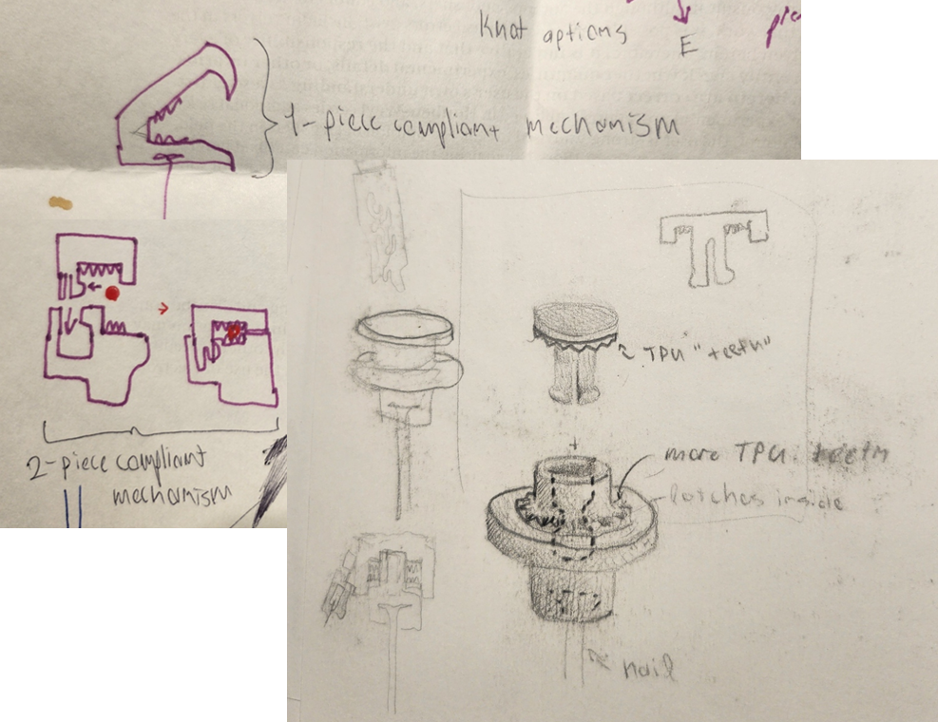
Figure 6. Sketches of Compliant Mechanism design concept and potential directions.

Concept 2: Weaving End Effector

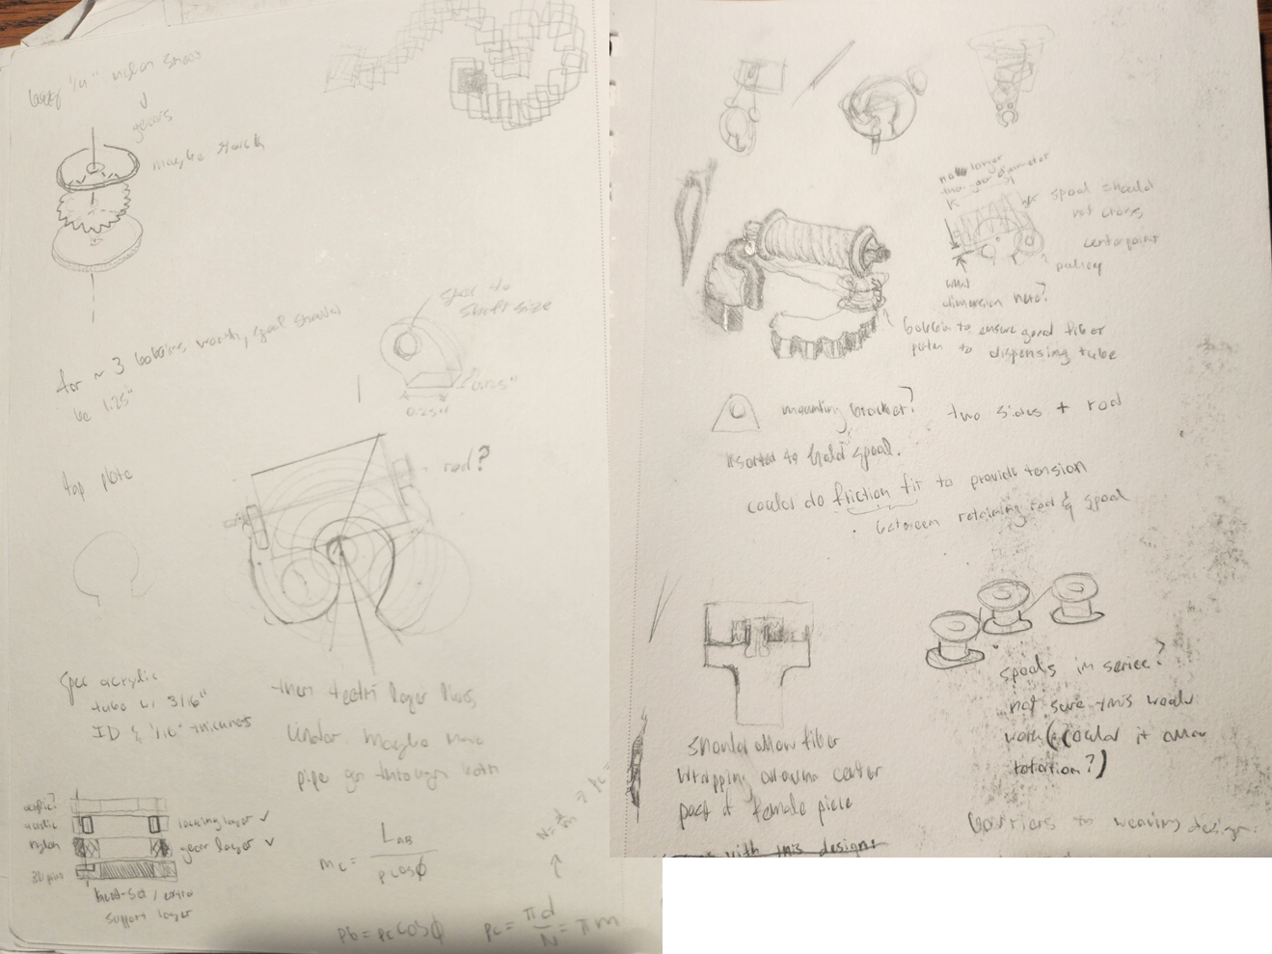
Figure 7. Sketches of Weaving End Effector Concept.

Bill of Materials

Figure 8. Screenshot of anticipated Bill of Materials for final prototypes.

Anticipated Supporting Analysis

Please see Section 2 for a comprehensive list of anticipated analysis.

Sponsor Approval

Yes. Dr. Sigal provided useful input on our design decision-making process and agrees with our team’s final decision.

6. Updated Project Plan

The capability of reliably producing yarn surrogates has many end users, from woven medical patches to increased strength in mass produced textiles. However, discussion with Dr. Sigal, the projects sponsor, has revealed that while these applications are definitely capable of being impacted, there is a more direct and immediate impact on the studies of glaucoma and the properties of the collagen fibers in the eye. The limitations in current computation models highlight a significance in producing a way to model the strengths and limitations of fiber-fiber and other complex interactions in the eye, and producing these physical structures is a direct step to solving this. As a result, while there is no direct change to our project plan of creating an end effector capable of outputting yarn and weaving, there is a shift of focus onto a new end user, the patients of glaucoma.

7. Updated Project Timeline

The timeline has been updated after each task is completed. It currently shows the tasks left to complete, and the completed tasks have been removed. The new task lists include the upcoming mini presentation and adapting the selected weaving design to attach to the robot. Like the previous tasks, the new tasks have been split into 1–2-day increments and assigned to the team members responsible for completing them.
